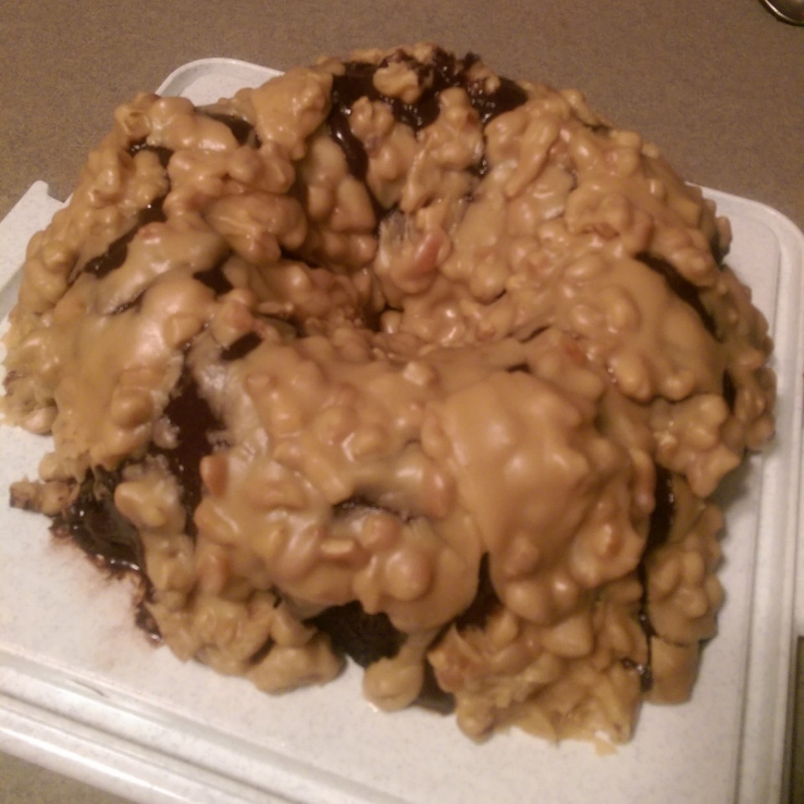
New Orleans Double-Chocolate Praline-Fudge Cake
Adapted from the recipe found in "Christmas with Southern Living 2005”
1 cup (2 sticks) butter (plus butter for greasing the pan)
1/4 cup unsweetened dark cocoa powder
1 cup water
1/2 cup buttermilk
2 large eggs
1 tsp. baking soda
1 tsp. vanilla
2 cups sugar
2 cups all-purpose flour, sifted (because I always sift)
1/2 tsp. salt
Preheat oven to 350 degrees. Grease a 10” Bundt pan thoroughly with butter (cooking sprays will drip down the sides and puddle in the bottom) and powder the whole pan with cocoa powder (you don’t want white flour on your pretty dark chocolate cake, do you?)
Combine butter, cocoa and water in a saucepan over low heat, stirring constantly, until butter melts and mixture is smooth; remove from heat. Cool.
The recipe says “beat” ingredients together. I use the whisk attachment on the mixer on most blending instructions. I think batters come out more appealing.
Beat buttermilk, eggs, baking soda, and vanilla at medium speed with an electric mixer until smooth. Add butter mixture to buttermilk mixture, beating until blended. Combine sugar, flour, and salt; gradually add to buttermilk mixture, beating until blended. (Batter will be thin.) Pour batter into prepared Bundt pan.
Bake at 350º for 45 to 50 minutes or until a wooden pick inserted in center comes out clean. Cool in pan on wire rack for as long as you can. Remove from pan and cool on wire rack, if needed. The first cake I made I tested it with a toothpick for doneness. Big mistake. The next cake I made I tested with a wooden barbecue skewer, and it came out clean all the way through the cake.
Before you go any further, make sure you read the rest of this recipe first, including the ganache and praline recipes. You’ll understand.
Cover cake with ganache, drizzling gently back and forth until the cake is covered; chill cake 30 minutes. Pour Praline Topping slowly over the top of cake, spreading to edges, and allowing some topping to run over sides of cake. Freeze, if desired; thaw at room temperature 4 to 6 hours.
Chocolate Ganache

(Here is the ganache recipe from Southern Living. I will admit, I failed at this twice before I decided to use the Dark Chocolate Frosting recipe from Martha Stewart that I used for the cake pops. See the frosting recipe at the end.)
2 cups (12 oz.) semi-sweet chocolate morsels
1/3 cup heavy whipping cream
4 tablespoons of butter, cut into pieces
Microwave chocolate morsels and heavy whipping cream in a glass bowl (50% power) 2-3 minutes or until morsels are melted, stirring after 1 1/2 minutes; whisk until smooth. Gradually add butter, whisking until smooth. Cool, whisking often, about 25 minutes or until spreading consistency. Yield: about 2 cups.
I used the microwave on one batch, then I tried the double boiler on the stove to make the ganache in another batch. Both batches “seized”. If you make it right, you’ll never know what that is, but if it happens, you’ll know it. In hindsight, two things could have happened. Make sure the butter for the ganache is room temperature; cold butter in the hot chocolate and cream mixture can cause seizing. Also, make sure no other moisture gets into the ganache, such as steam from a double boiler. I hope my experience helps someone. I will try ganache again…some day.

Praline Topping (only a saucepan required)
Do not prepare ahead of time or it will harden, and that is no joke. This praline is delicious and a big crowd pleaser. I will be making it again, all by itself, or on chocolate. It was the easiest part of the whole recipe. It hardens very quickly so it’s hard to make your dish look refined or elegant, or I speak for myself.
1/4 cup butter
1 cup firmly packed light brown sugar
1/3 cup heavy whipping cream
1 cup powdered sugar
1 tsp. vanilla
1 cup chopped pecans, toasted
Bring butter, brown sugar, and heavy whipping cream to a boil in a 2-quart saucepan over medium heat, stirring often; boil 1 minute. Remove from heat, and whisk in powdered sugar and vanilla until smooth. Add toasted pecans, stirring gently 3 to 5 minutes or until frosting begins to cool and thicken slightly. Pour frosting immediately over cake.
This mixture is still going to be a little warm. Prepare for some of the ganache (or frosting that I piled high) to melt and slide down the cake. This was remedied by covering it all with the Praline frosting. Remember, it’s going to harden pretty quickly so get it on there the way you want it right away! You can tell how I did from the picture. It looks like a volcano but it’s so delicious!

Here’s the Martha Stewart Dark Chocolate Frosting in the event you are like me and struggle with ganache:

Ingredients
- 1/2 cup plus 1 tablespoon unsweetened Dutch-process cocoa powder
- 1/2 cup plus 1 tablespoon boiling water
- 2 1/4 cups (4 1/2 sticks) unsalted butter, room temperature
- 1/4 cup confectioners' sugar, sifted
- 1/4 teaspoon salt
- 1 1/2 pounds best-quality semisweet chocolate, melted and cooled

Directions
Combine cocoa and the boiling water, stirring until cocoa has dissolved. With an electric mixer on medium-high speed, beat butter, confectioners' sugar, and salt until pale and fluffy. Reduce speed to low. Add melted and cooled chocolate, beating until combined and scraping down sides of bowl as needed. Beat in the cocoa mixture.

